**Cassab, Judy (b. 1920, Vienna--)**

Judy Cassab is a celebrated portrait and landscape painter, as well as a printmaker. Painting in her own distinctive expressionist style, her work employs both figurative and abstract elements. Known for her capacity to catch effective likenesses of her sitters, she prefers to dig deeper into character and focus on the psychology of her subject. Once claiming she wanted to bring the portrait ‘back into the twentieth century’, she works intuitively, doing very limited sketches before beginning a painting. After making what she calls ‘shorthand notes’ she then focuses on the colour of the painting, what she refers to as the ‘inner colour’ of the sitter, so they might be a ‘blue’ person or a ‘yellow’ person. Rather than starting with a white canvas she uses this ‘inner’ colour as the base and then the portrait itself and other colours are built up over the top, with the base colour setting the unifying rhythm. This way she ensures there is no radical schism between the background or the clothes and the face itself. This technique is evident in her Portrait of Margo Lewers from 1967, in which the overall colour unifies the composition.

[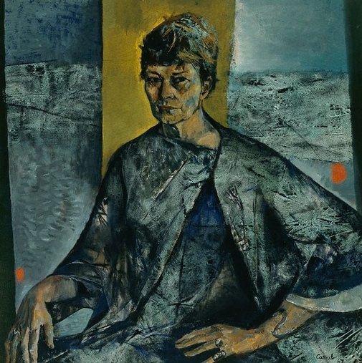](http://www.artgallery.nsw.gov.au/media/collection_images/Alpha/OA5.1968##S.jpg)

Judy Cassab, *Portrait of Margo Lewers*, 1967, oil on canvas, 101.5 x 101.5 cm, Collection: AGNSW, Accession No. OA5.1968, Copyright c/- Art Gallery of NSW

Living in her parents’ native Hungary from the age of twelve until after the Second World War, she attended classes at the Academy of Art in Prague in 1938. Of Jewish ancestry, she avoided the concentration camps by living under an assumed name and away from her husband John (Janesc) Kampfner. Kampfner had been forced into labour camps and encouraged her to continue her art studies in his absence, which she did with Aurel Bernth and Lipot Hermann at the Budapest Academy (1941). Arriving in Australia in 1951 she quickly established herself as a portrait painter, first approaching Sir Charles Lloyd Jones with a letter of introduction. He was already having his portrait done by William Dobell but he asked Cassab to paint his wife, and from then on the commissions flowed. She has painted many well-known people, both in Australia and internationally.

Cassab made several trips to central Australia, the first to Alice Springs in 1959 where began to work on landscape, particularly images of desert and rocks. She described this first visit as a revelation, saying ‘*now* I knew why we had immigrated to Australia. I felt like Ali Baba discovering the treasure cave. I felt greedy. I wanted it all. I began 14 pictures in a week. I have never experienced such colour. It was like a physical force hitting not only from the front, but sideways and from the back as well.’

Cassab has also commented that she never set out to be a commercial portrait painter and was well aware that for a long time it was looked down upon. She described herself as feeling ‘schizophrenic’ when doing a huge body of work that had nothing to do with portraiture.

In 1953 she had her first Australian solo exhibition at Macquarie Galleries, Sydney. She has won many awards including the Australian Women’s Weekly Prize in 1955 and 1956; the Archibald Prize 1961 with a portrait of fellow immigrant Stanislaus Rapotec (being the second woman to win); the Archibald Prize again in 1968 for her portrait of artist Margot Lewers; the Helena Rubinstein Prize in 1964 and 1965; a CBE (Commander of the Most Excellent Order of the British Empire) in 1969; and an Order of Australia in 1988.

**References and further reading:**

Cassab, Judy. (1996) *Judy Cassab Diaries*, Sydney: Random House.

Gleeson, James. (1978) *James Gleeson Oral History Collection, James Gleeson Interviews Judy Cassab*, Canberra: NGA.

Klepac, Lou. (1988) *Judy Cassab: Artists and friends*, Sydney: Beagle Press.

Niall, Brenda. (2005) *Judy Cassab: A Portrait,* Sydney: Allen and Unwin.

…